Functional adaptation of microbiotic Pseudomonas to vertebrate host classes



Tobias Nunn
A dissertation submitted in partial fulfilment of the requirements for the degree of BSc/MZool in Zoology
School of Natural Sciences, Bangor University
Academic year 2025-26

Supervised by [supervisor’s title] Aaron Comeault

Declaration
By submitting this dissertation, I confirm that I am familiar with Bangor University’s rules about unfair academic practice, including plagiarism, self-plagiarism, and collusion, and have had a chance to discuss any concerns with my supervisor. I confirm that this assignment is all my own work and that I did not use AI to produce any of the text. I also confirm that no part of this text has been submitted for academic credit before (including for BSX-2021).
Student name: Tobias Nunn Date: [give the signing date]
Signature: [add an electronic signature here]


Gen-AI in assessment declaration
Student 500 number: [check your student number] 500690571
Module Code: BSX-3070
Assessment: Dissertation write-up
Assessment’s Gen-AI Category (see the Assessment Brief): 2

The following statement reflects my use of Gen-AI within this assessment (select all that apply):
Description of use | Select (X)
Gen-AI has not been used at all in producing this assessment.
Gen-AI was used in an assistive role to research topics and provide explanations. | X
Gen-AI was used in an assistive role to suggest sources of information, e.g. publications to read. | X
Gen-AI was used in an assistive role to summarize the content of publications or other sources. | X
Gen-AI was used in an assistive role to produce an outline or draft structure of my assessment.  Note: for Category 2 assessments, the fundamental content of the submission (e.g., the arguments, interpretations, conclusions etc) must be your own. | X
Gen-AI was used in an assistive role to improve spelling, grammar, sentence structure and/or clarity of expression of my assessment.  Note: for Category 2 assessments, the basic written expression must be your own. Therefore, whilst Gen-AI may correct mistakes it must not produce the actual content. | X
Gen-AI was used in an assistive role to translate text during the production of the work.
Gen-AI was used in an assistive role to analyse data and/or produce visualizations of data. | X
Gen-AI was used in an assistive role to help produce creative outputs e.g. art, imagery, movie, music, creative writing.
Gen-AI was used in an assistive role to refine computer code and/or other output. | X
Gen-AI was used in another assistive role (please describe):
Gen-AI was fully used to complete a Category 3 assessment and use complied with the assessment instructions provided.

By using this cover sheet and entering my student ID above, I declare that I have provided honest and accurate details regarding my use of Gen-AI within this assessment.

Functional adaptation of microbiotic Pseudomonas to vertebrate host classes
Using KO pathways as the tool of study [it said I should do a sub-title]

Abstract
This contains the main abstract text written as a single paragraph, of no more than 300 words. Please note that the abstract word count is included in the 6,000-word maximum for the thesis.

Keywords
List up to six keywords that do not repeat the title of the dissertation here. Separate each keyword with a comma or a semi-colon.
Microbiome; Host-association; Gene-enrichment; Functional-Genomics;

Introduction
Write paragraphs in this style. This includes 1.5-line spacing, 12-point text and a 6-point gap at the end of a paragraph, plus an indent to start the next one. Remember that in-text citations count towards the main text word-count. Your main text, including in-text citations in Harvard style, should be less than 6,000 words (no +/- 10% applies here). Main text ends at the end of the Conclusion, before the Author Contributions, Acknowledgments and References. Table contents and Table and Figure legends do not count towards the 6,000 words.

Use this style for a first-level subheading

Use this style for a second-level subheading
Remember that you should have no more than three heading levels, or individual sub-sections will get too short and bitty.
“Writing a long quote [40 words or more]? It should go in this style, with the citation immediately below and left-justified. Use direct quotes very sparingly.”
Citation for the direct quote.
At the end of the Introduction, you need to give your aim and either two-three objectives (objectives are statements of what you will do to achieve your aim) or a hypothesis and predictions. You should consult with your supervisor about which is appropriate for your project. I recommend writing the aim – which every project will have – as part of a normal paragraph, like this, then saying you have several objectives or hypotheses:
- Here’s an objective formatted as a numbered item
- Here’s another
H₁ = this is a hypothesis
H₀ = a null hypothesis

[Intro to the host-associated microbiome]
(Parfrey et al., 2018) – review paper of microbiome, will have useful refs that can help expand
(Wilkins et al., 2019) – paper on marine importance, could be good to showcase practical applications of microbiome analysis
(Ganesan et al., 2020) – paper on mechanisms of bacterial establishment, good to talk about host – microbe coevolution and relationships, perhaps even exact mechanisms behind mutual relationships with host
[introducing Pseudomonas as a model organism for bacteria]
(Stover et al., 2000) – BIG, landmark paper on Pseudomonas, first to sequence whole genome, gives much important information. Abstract alone: opportunistic pathogen (important to study), AMR (important to study), “large number of genes involved in the catabolism, transport and efflux of organic compounds as well as four potential chemotaxis systems.” (potential mechanisms to research) and ubiquitous (allows study across host Classes, compared to more specific bacteria, helps answer why use this genus)
(Spiers et al., 2000) – evidences long history of the genus for genetic / genomic study, mentions genetic adaptability, helps evidence why the genus was chosen, builds up to the precise ways it adapts in the paragraph that introduces the study
(Krell and Matilla, 2024) – recent paper, many complex words, discusses P. aeruginosa as a model for “two-component systems”, biofilm formation and secretion systems, as well as “chemosensory pathway signalling”. Point is, many potential mechanisms to say why genus was chosen. Potentially very useful paper more generally to discuss the genus. Ah, not a full paper, merely an article, should still have good references
{somewhere in intro, clinical relevance can be illuded, connect to limitations of study in methods and discussion}
[learning more about the relationship between microbiome and host lifestyle]
(Song et al., 2020) – paper on gut microbiome for flyers, could help introduce the study, differences between aerial and terrestrial lifestyles showing differences for microbiome.
[Use of public data repositories]
Word count limited to 6k, may not be enough to include this as its own paragraph, think it should just be quickly introduced with sentence in methods, limitations of data discussed elsewhere
[Introduce the study]
“In this study, the mechanisms by which Pseudomonas bacteria adapt to their host will be tested. Specifically, Rates of enrichment for [X mechanism introduced in par 2] will be compared between host classes ranging from Vertebrates like Mammalia and Amphibia, to Invertebrates like Nematoda and Insecta. Previous studies have shown X mechanism to very throughout these groups. As an adaptive species (one of those refs from up there), Pseudomonas is expected to change or regulate (the WGS paper) mechanism X in response to these differences. Specific differences driving this change in mechanism X include [fill in, in what way do mammals and birds differ that make M-X change?]”
{biofilm formation is a good candidate, if so, something like:}
“Due to the ubiquity of Pseudomonas species in the environment (ref), it would be understandable that environmental individuals could colonise hosts with relative ease, this is seen in a pathogenic capacity (ref). Due to the differences in skin makeup between major vertebrate and invertebrate lineages, the requirements for binding to the external surface are different. This will drive differential gene expression of genes associated with biofilm formation, for which Pseudomonas is a model (ref). {important note if doing this} It should be noted that the makup of the skin is not ubiquitous across individuals, with different excretions and e.g. hair in mammals across the body. {… but I cannot account for that, limitation of the study}
{right, the most important bit, the bit where I state the aims and the hypothesis}
“The aim of this study is to help more fully characterise the manners in which large-scale variation in putative hosts can impact gene expression in the adaptive genus of bacteria Pseudomonas. Specifically, it is hypothesised (H₁ =) that (e.g.) these wide-scale differences seen between external surfaces of various animal Classes will have measurable impacts on the rate of expression and regulation for biofilm formation genes, used in colonisation. It is predicted that… {would need to look into papers on biofilm formation more to estimate how exactly this would change, and also how they work exactly}. This is important knowledge as… {how is this pushing the envelope of science to know that biofilms are more regulated in fish than mammals? Some link to pathogenesis? Admittedly, this is more relevant for conclusion, but its an important question of how to bridge the gap of the “how”, to the “why”}”

Method
Any figures or tables that you use in your text must be mentioned in the text before they appear – don’t put the figure or table and then describe it, tell the reader what they are about to encounter then show them it. Each figure must have a legend underneath it, and should not also have a title above. If you use the figure legend and table legend styles, they will allow you to use cross-references to mention the figures in the text. Here’s an example – go look at the image below (Figure 1), which shows some simple rules for making figures, and Figure 2 which shows how to set up a cross-reference. If you click on the text of “Figure 1” in the brackets above, it goes grey – this means it is an active cross-reference and will take the reader to the figure if they click on it with a mouse while holding the Control key down. This is helpful in navigating! To add a cross-reference, put in a figure, right-click on the figure and select ‘add caption’ and then put your cursor in the text where you want to mention it. Go to Insert on the Word menu and click ‘cross-reference’. Set it up the way it looks in Figure 2, so it points to the caption of the figure you want to mention and will only insert the label and number into the text. Click Insert.
Your Method section may contain figures or tables, e.g. a list of datasets collected. It should not contain any results, so no descriptions of what your data showed. Most figures and tables will therefore be in Results. For a systematic literature review, a PRISMA flowchart might go here. Other types of project might include maps of locations studied, etc.
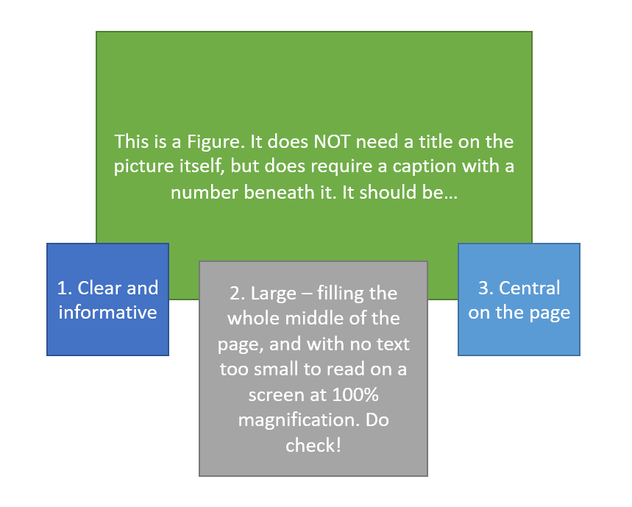
Figure 1: an example figure with some notes on size and placement. It’s quite big, and the next one has fallen onto the next page of the document. That’s OK – don’t be tempted to make it smaller to squeeze both onto the one before! All that does is make the figure impossible to read. Figures do not want to be embedded in text (so the text wraps around the figure) – they should take up most or all of the page width. This is a legend, written in caption style. To add a legend, right-click on your picture and select “Insert caption”.

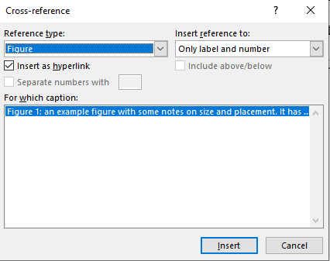
Figure 2: another figure, showing how to set up a cross-reference so that figure numbers will automatically update. Figure legends do not count towards your 6,000 word maximum.
There will be more text below each figure or table, which as you’ll see looks different to the caption – we’re back to paragraph style here.
Ethics Statement
Your method must end with an ethics statement. If no ethical issues were identified and you didn’t need to complete the CoESE ethics forms, you should say ‘This research was screened under Bangor University’s Research Ethics Framework and no issues were identified’. If you did do an ethics form, this section should describe the potential issues raised and how they were mitigated. Signed ethics forms should then be included in your appendix.
[Metadata collection and filtering] {this paragraph is a bit janky in retrospect}
Metadata was obtained from public accessions, available on the NCBI genomic database (ref or link). All ~99,000 accessions with the genus of Pseudomonas, as of the 8th of December, were downloaded. They were then filtered to just those of interest to this study. As in, only accessions collected from wild animal hosts were kept. This removed the vast majority, as many either were lacking host information or were taken from humans in a clinical setting. Domesticated animals were {I am going to need to do smth about that, at the moment the domestic animals are still in play, as I forgot this step when filtering, but it may be a limitation of the study that cutting them leaves me with too few, or there are too many ambiguous ones}. The accessions were then filtered again to remove any low quality samples, wherein they had a CheckM completeness and contamination below 95% and 5% respectively {also have not yet seen what doing this would do to the data, need to check if this is right}. The generative AI tool Claude.ai was used to place these accessions into groups based upon the host taxonomic Class. This method was chosen due to the lack of consistency with entries in the host field, ranging from latin scientific names to English common names to misspellings and colloquial names. This tool was much faster than humanly possible, it was however checked for mistakes {A. the first part of this sentence is a mess, B. that is a lie in the second, gotta get around to that}.
[Descriptive analysis]
Once groups were decided on, descriptive analysis of the data could be performed. Firstly, tables were made to characterise the count of accessions per host group, as well as the number of accessions per species of Pseudomonas. After this, a phylogenetic tree was created to display the phylogenetic diversity of the accessions, this was made using the tool GTDB-Tk. These descriptive analyses in turn helped characterise to what level filtering should be applied, whilst still maintaining a good number of accessions in the dataset. {this paragraph needs building up, or incorporating into another one}.
[Data processing pipeline]
The remaining accessions could then be processed. Only here was the genomic content of the accessions downloaded off of the NCBI, as downloading such a vast amount of data only to delete 99%+ of it would be wasteful of time. The genomic sequences of the accessions first needed to be translated into protein sequences. This was done using Prodigal (easy ref) {version ___}. These protein sequences then needed to be annotated for the genes present. This was done using EggNOG-mapper (ref) {version ___}. Finally, the annotated sequences needed to be enriched for KEGG (ref) data. This was done in R using the “enrichKEGG” function of the “ClusterProfiler” package. This outputted… {how do I characterize the output of this?}. Code / scripts (and more exact methods) used in this pipeline are available on the GitHub Repo for the project: (link)
[Data analysis and statistics]
Averages for the proportions of gene expression could be calculated, in R, inside of groups. This gave averages for gene expression for any given KEGG pathway inside of that group. These could be plotted on a heatmap where any one group had a >80% enrichment for that pathway and the rest had a combined average of <50%. {is that the play anymore? Feels like the real thing to do would be to filter to only genes that KEGG decide are a part of systems for (e.g.) biofilm formation} This allows comparison for those pathways between each of the groups with enough accessions. Statistics can be performed on the differences seen, such as the chi-squared test {is that the right statistic?}.

Ethics statement
This research was screened under Bangor University’s Research Ethics Framework and no issues were identified {is that true, or am I making that up?}

Results
Here is where your findings go. Write in paragraphs and use figures and tables where needed. Tables are a little different from figures because they have their captions on top rather than underneath – but you add one in the same way. You can cross-reference it using the same technique as described above. Make sure you think about layout and how the data is best presented (see Table 1). Your results section should always start with text, and each table should be referred to before it appears.
If you have complicated and large tables to add, consult with your supervisor. It might also be useful to put the table on a different page and set that page to landscape orientation (using section breaks before and after to ensure the formatting only affects the table itself), if the table is wide and not too long and absolutely has to go in the main text.
Table 1: this is a table legend. To add it, click on the table and then right-click on the plus sign in the top-right corner. Select Insert Caption and make sure the drop-down menu inserts something that says “Table” not “Figure”! Table legends and table contents do not count towards your 6,000 word maximum.
Column 1 heading  Make headings clearly distinct from the rest of the table content, e.g. in bold | Column 2 heading
Consider whether this text should be centralised, justified or not based on what makes the table easier to read | More information
Justified text usually works well here
Make sure you format tables the same way throughout, if you don’t use the Table Content and Table Heading styles set up for you. Do not put text smaller than 10pt in a table.
Remember in “Table Design” you can add thicker borders to specific parts of the table, use colour on rows or columns, etc.

[first table counting by host]
Firstly, the number of accessions in each host group needed to be characterized. This was done simply using a datatable, created in duckDB using a SQL query on the metadata. This produced Figure 1 {it will be Fig1 when the 2 in the template are removed}. This displays the top 10 rows. The total number of accessions in the dataset is 486, with the 5 largest groups being Mammalia, Actinopterygii, Insecta, Aves and Amphibia. These are the 5 host Classes for which there is adequate data (over 30) for data analysis {should I drop this to 10 to include reptiles and crustaceans, or is that too few?} . It should be noted that hosts of ambiguous domestication were included in analysis, as it was concluded removing them could decrease the number of useable samples to an unworkable degree.
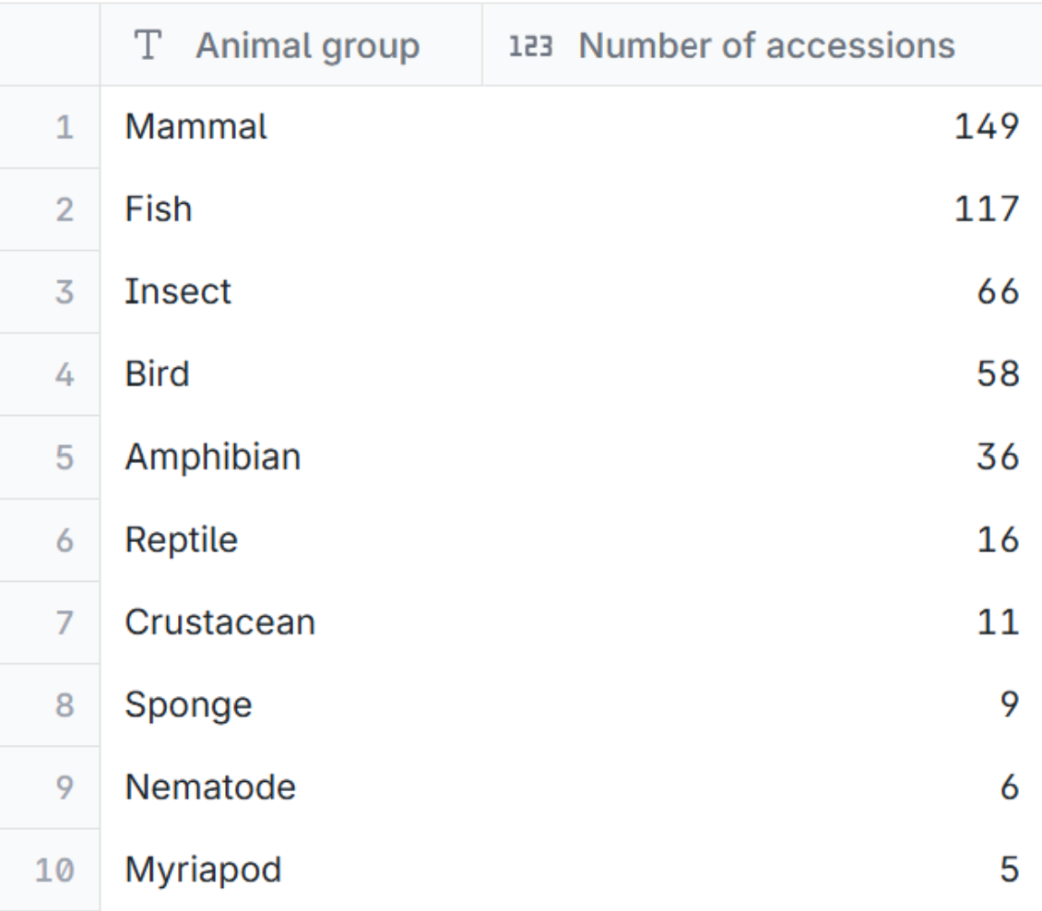
Figure 3 - count of accessions in the dataset by the group their host is associated with. It should be noted that “Fish” was used accidently as an over-simplification of ray-finned fish, and the Class of interest is Actinopterygii.

Figure 2 presents a similar table, also showing the 486 accessions, this time broken down by the species of Pseudomonas. Understandably, the species with the most accessions is P. aeruginosa. However, this is the only species with enough accessions for analysis, should that be performed {am I going to do an inside-species analysis?}.
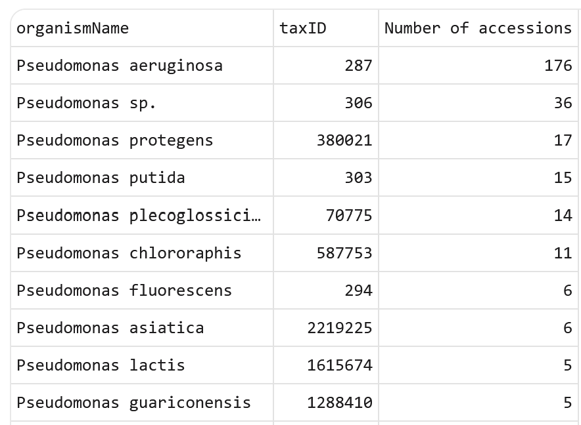
Figure 4 - table showing the number of accessions for each of the top 10 species of Pseudomonas.

Figure 3 displays a phylogenetic tree of the data. This was made to display the relationships between accessions, and characterise if there are correlations between evolutionary history and host demography.
{Figure 3 yet to be made}
Figure 4 displays the differences between the 5 host groups for enrichment in KEGG pathways involved in {e.g.} biofilm formation.
{Figure 4 yet to be made}
{There may be more after this depending on what secondary analysis could be performed, such as a heatmap showing the differences inside of P aeruginosa, if there are enough strains, unsure at this time}

Discussion
Don’t forget you need a discussion. This should evaluate and interpret your Results, and refer to others’ similar studies. The Discussion and the Introduction together are where you make your arguments and should contain most of your in-text citations.
[Limitations of the study]
The study was limited by the quantity and quality of the data available on the NCBI genomic repository. The genus Pseudomonas was chosen, in part, due to the fact that only the most well-studied bacterial species contain sufficient host data for adequate analysis. This is because for many taxa on the database, only a very small proportion of samples even have a host field in the metadata to begin with {visualisation?}. A problem which could not be avoided for this species is that much of the remaining samples come from humans and livestock, meaning the proportion from wild animals is relatively low. This is easily seen in this study, with ~59,000 Pseudomonas accessions in the database, but only 486 accessions able to fit the parameters of this study.
{breakdown – quantity issues – very few of the accessions have something in the host field / quality – what there is is mostly NA or misspellings or other such not-useable}
[Next steps]
“These methods can be used for any bacterial organism and functional molecular mechanism which exists” – {thus future researchers can make use of the pipeline for their own ends, or something in that vein}
“future researchers should ensure that their taxa of study has enough accessions to overcome the quantity and quality issues, should analysis based on fields of the metadata be done. However, there is potential for this area of study.”
“A standardisation of the data fields in the metadata on the database is recommended to increase the quality of the data.” {point of this is that a good next step is to somehow try to address the quality and quantity issues}

Conclusion
Do not allow your conclusion to bring in new facts or opinions. It’s just a summary! The end of the conclusion is where you stop counting words towards your 6,000 limit.

Author Contributions
You are required to provide a brief summary of your role in the project in this section – this is normal practice in science and ensures that scientists are transparent about their work and who helped them. None of us can do a project on our own, and it is only ethical to mention who did what. It can be hard to do this appropriately and clearly in the main text.
Your author contribution statement is not marked, but your supervisor will be asked to consider whether it is accurate. It should mention all the roles you performed, and which tasks were shared by you and your supervisor or done by someone else entirely, e.g. if you used data collected by last years’ students. Mention who came up with the original idea (you, your supervisor or both), developed the project design, collected the data, analysed the data, co-ordinated the work, did the writing and/or editing and provided feedback. Your supervisor should be mentioned as providing supervision at least! You can use the CRediT taxonomy as a starting point, though some of the activities it suggests (e.g. obtaining funding, designing software) might not be relevant to most people and can be ignored unless they are.
Remember, what we are looking for here is an accurate and honest appraisal of what you did and what others contributed to your project – we are not marking this. There is no extra credit for saying you did everything yourself, and you will absolutely not be at a disadvantage from expressly acknowledging help and support from others.

Acknowledgements
There is no obligation to have acknowledgements, but they can be useful if you have other people to thank, e.g. the person who made the million-and-one cups of tea that kept you sane or the friend who proofread for you!

References
Add your references here, in Harvard style. You can do this with Mendeley or by hand – but I recommend Mendeley. Use the ‘BSX-3070 Harvard’ style, which you can download at the link on Blackboard. This is what a standard reference will look like:
Author, I. (date). Example paper title. Journal it was published in, 1(3): 1-11.
Author, I. (date). Book title. Place of publication: publisher.
There will be different elements to a reference depending on what kind of book (edited books are different, as are chapters in them). Websites also have their own rules and information they must include – the detail is in the Mendeley style or on Blackboard.

Appendices
You may have appendices – but ideally not more than 5 pages. If you plan more, consult your supervisor. Data tables and so on should be in a data archive, not here. Appendices start on a separate page, and are lettered (e.g. Appendix A, Appendix B etc.).

